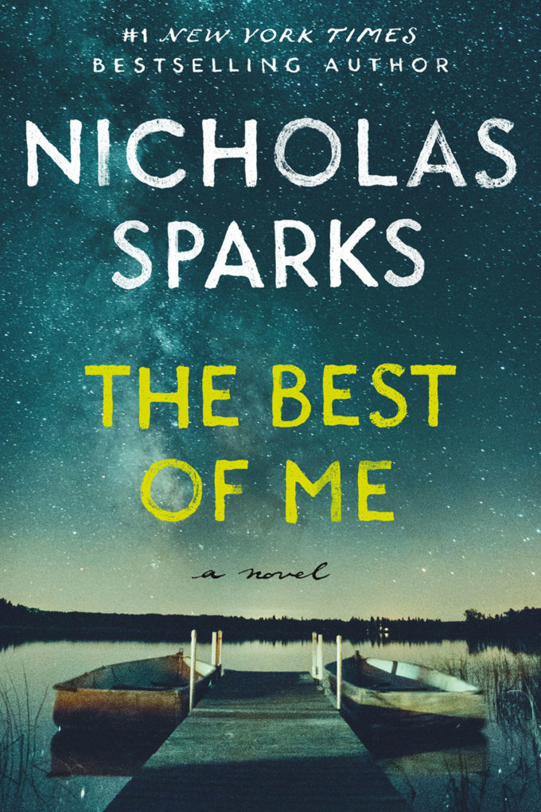
The Best of Me
by Nicholas Sparks

This is the story of two small-town former high school sweethearts from opposite sides of the tracks. Now middle-aged, they have taken wildly divergent paths, but neither has lived the life they imagined, and neither can forget the passionate first love that forever altered their world.

